POTTERY PAINTING & AFTERNOON TEA
At The Clay Cottage, Lubbards Farm,
Hullbridge Road,Rayleigh. SS6 9QG

Saturday 1st October from 1.30pm
(after the COPES meeting so we can hopefully arrange lifts if needed)

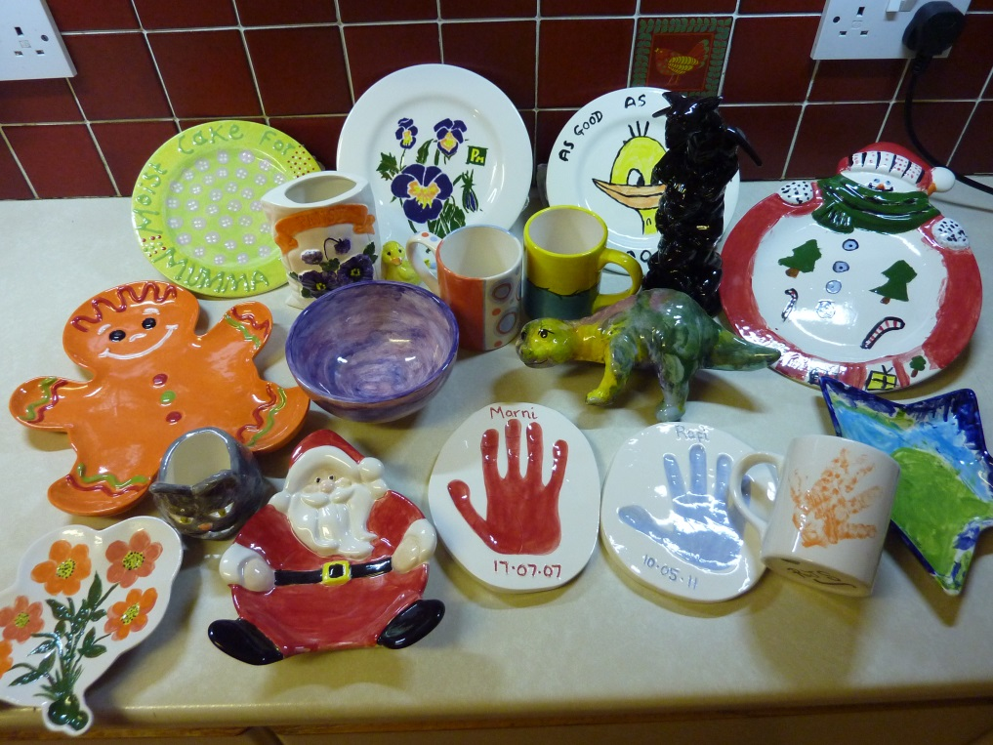

Cost £7.50 per person for the tea
Costs for the pottery selected to paint vary from £5

Come along for a fun afternoon. You don't have to be artistic it’s great fun.

Please let me know if you're interested and I'll add your name to the list. sue-soper@sky.com / 07768 619495

£5 deposit required please to ensure booking.

