COPES FUNDRAISING CURRY NIGHT
23rd September 2016
7.00 for 7.30 p.m.
Regency Spice Restaurant, Rochford.
Back Lane, Rochford, SS41AY
Ample parking in nearby Public Car Park
A fabulous night out with Raffle.
Invite family and friends.
£15 per person
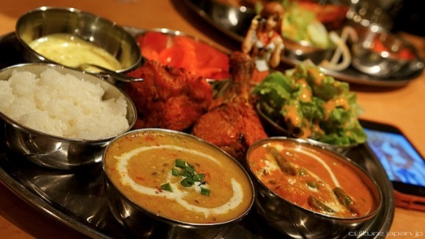
Buffet meal.
English menu available.
For further info (including deposit details) & to book places contact c.roostan@tiscali.co.uk or at Sept. Coffee Morning.

