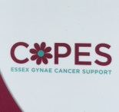
AUGUST NEWS 2016
PHOTOSHOOT!
Some of us went along to Priory Park last month to help Target Ovarian Cancer with photos for their info leaflets. They wanted women who looked friendly and were at ease with each other to show in a variety of settings. It was great fun! Thanks to Wendy Barker for organising this.
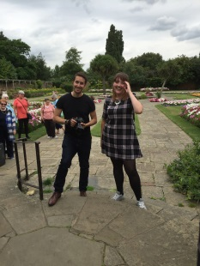
Forthcoming Events:-
September 23rd………We have had to postpone the Dinner Dance due to organisational reasons but we’re bringing forward the Curry Night to that date. Details of venue to be announced. If you’re interested please let Chris Roostan know. We need to know possible numbers. This will be an event which is also open to friends and family as well as COPES members.
Sept 18th 2016 Walk for wards –Hospital charity /COPES (look out for information)
Oct 1st 2016 Pottery painting tea party at Clay Cottage, after coffee morning.
Nov 5th 2016 Impressions Accessories sale, at coffee morning.
Nov 23rd 2016 “Sister Act” at the Cliffs . Free for COPES members.
Please let Chris Roostan know, as soon as possible, if interested.
Dec 3rd 2016 Christmas bazaar . Any Raffle and Tombola Prizes gratefully accepted.
Raffle, Nearly new gifts and trinkets, mince pies and mulled fruit cup.
Feb/Mar ’17 Dinner Dance. Date, Venue and ticket price to be announced.
We had a great time at the Cliffs Pavilion for Afternoon Tea. Thanks to Chris for arranging this!
